

**Mathematics Applications  
Year 12**

**Investigation 4 – Reachability and Dominance**

**Semester 2 2018**

**Time allowed:** 50 minutes

**Marks Available:** 105 marks

**Materials required:** Writing implements, correction fluid/tape or eraser, ruler, Scientific or CAS calculator

**Instructions:**

1. Write your answers in the spaces provided in this Question/Answer Booklet.
2. **Show all your working clearly**. Your working should be in sufficient detail to allow your answers to be checked readily and for marks to be awarded for reasoning. Incorrect answers given without supporting reasoning cannot be allocated any marks. For any question or part question worth more than two marks, valid working or justification is required to receive full marks. If you repeat an answer to any question, ensure that you cancel the answer you do not wish to have marked.

1. (27 marks)  
   Consider the Directed Graph (Digraph) below:

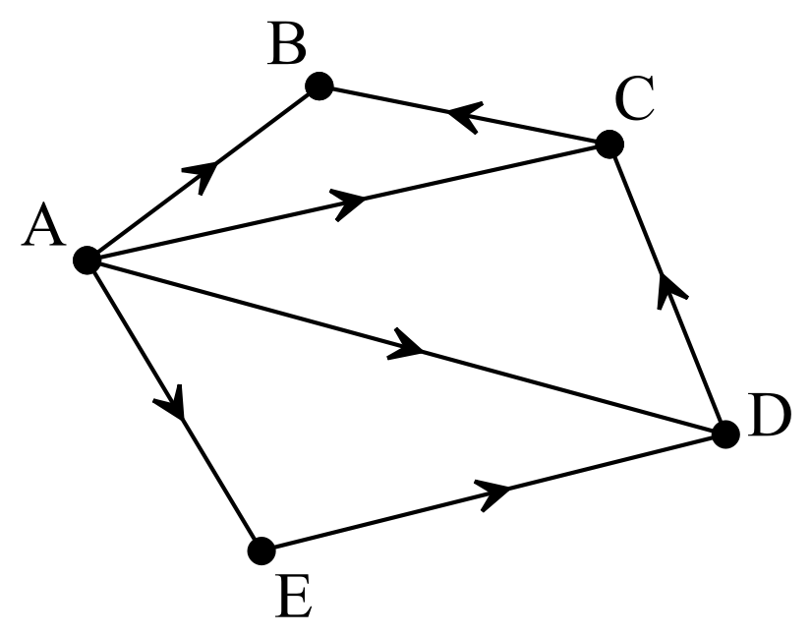

This graph represents connections between points.

1. How many connections are there that involve one-step (i.e. a one edge connection)? List each connection using the notation  . [7]

1. Connections can be represented in a matrix. Use the information gained in **1a** to complete the matrix below. [5]

|  |  |  |  |  |  |  |  |  |
| --- | --- | --- | --- | --- | --- | --- | --- | --- |
|  |  |  | **To** | | | | |  |
|  |  |  | A | B | C | D | E |  |
| **From** | A |  |  |  |  |  |  |  |
| B |  |  |  |  |  |  |  |
| C |  |  |  |  |  |  |  |
| D |  |  |  |  |  |  |  |
| E |  |  |  |  |  |  |  |

1. How many connections are there that involve two steps (i.e. a two edge connection)? List each connection using the notation  . [5]

1. Use the information gained in **1c** to complete the matrix below. In this matrix, a two-step connection is shown as a 1 linking the first and last vertex of the connection. [2]

|  |  |  |  |  |  |  |  |  |
| --- | --- | --- | --- | --- | --- | --- | --- | --- |
|  |  |  | **To** | | | | |  |
|  |  |  | A | B | C | D | E |  |
| **From** | A |  |  |  |  |  |  |  |
| B |  |  |  |  |  |  |  |
| C |  |  |  |  |  |  |  |
| D |  |  |  |  |  |  |  |
| E |  |  |  |  |  |  |  |

1. Are there any three-step connections in the network? If so, list them below. [3]

1. Complete this matrix for **1e**. [2]

|  |  |  |  |  |  |  |  |  |
| --- | --- | --- | --- | --- | --- | --- | --- | --- |
|  |  |  | **To** | | | | |  |
|  |  |  | A | B | C | D | E |  |
| **From** | A |  |  |  |  |  |  |  |
| B |  |  |  |  |  |  |  |
| C |  |  |  |  |  |  |  |
| D |  |  |  |  |  |  |  |
| E |  |  |  |  |  |  |  |

1. Are there any four-step connections in the network? If so, list them below. [1]

1. Complete this matrix for **1g**. [2]

|  |  |  |  |  |  |  |  |  |
| --- | --- | --- | --- | --- | --- | --- | --- | --- |
|  |  |  | **To** | | | | |  |
|  |  |  | A | B | C | D | E |  |
| **From** | A |  |  |  |  |  |  |  |
| B |  |  |  |  |  |  |  |
| C |  |  |  |  |  |  |  |
| D |  |  |  |  |  |  |  |
| E |  |  |  |  |  |  |  |

The first matrix that we determined was known as the **Adjacency Matrix (C1)**. All the matrices are known as **Connectivity Matrices**. We can determine each of these subsequent connectivity matrices using the ClassPad.

The following example will require you to utilise your ClassPad to determine the required connectivity matrices.

1. (19 marks)  
   Consider this graph:

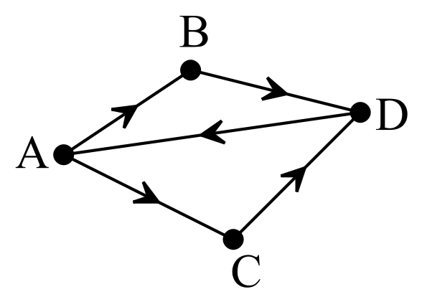

* 1. How many vertices are there? [1]
  2. How many edges are there? [1]
  3. Record the one-step connections in the Adjacency Matrix (C1) below (be systematic). [4]

|  |  |  |  |  |  |  |  |
| --- | --- | --- | --- | --- | --- | --- | --- |
|  |  |  |  | | | |  |
|  |  |  | A | B | C | D |  |
| **C1 =** | A |  |  |  |  |  |  |
| B |  |  |  |  |  |  |
| C |  |  |  |  |  |  |
| D |  |  |  |  |  |  |

You will now enter the Adjacency Matrix into your ClassPad.

Go to **Main** and select **Keyboard** and **Math2**

Press the **Matrix** icon four times to obtain a 4 x 4 matrix. Enter the matrix and put it into memory **a** as shown thenby press **EXE.**

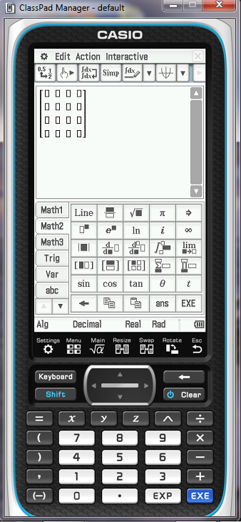 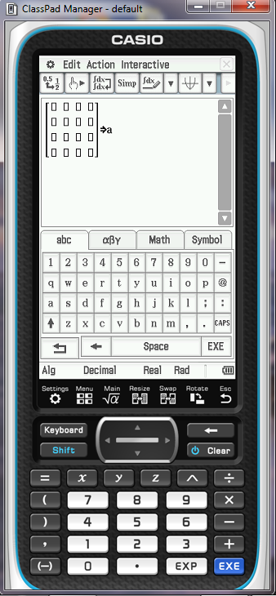

* 1. Determine C2 and C3 using your ClassPad. [4]

To determine C2 and C3 all you need do is **square a (a2)** and **cube a (a3).**

|  |  |  |  |  |  |  |  |
| --- | --- | --- | --- | --- | --- | --- | --- |
|  |  |  | A | B | C | D |  |
| **C2 =** | A |  |  |  |  |  |  |
| B |  |  |  |  |  |  |
| C |  |  |  |  |  |  |
| D |  |  |  |  |  |  |

|  |  |  |  |  |  |  |  |
| --- | --- | --- | --- | --- | --- | --- | --- |
|  |  |  | A | B | C | D |  |
| **C3 =** | A |  |  |  |  |  |  |
| B |  |  |  |  |  |  |
| C |  |  |  |  |  |  |
| D |  |  |  |  |  |  |

* 1. We will now add together C1, C2 and C3. [2]  
       
     Enter **a + a2 + a3**

|  |  |  |  |  |  |  |  |
| --- | --- | --- | --- | --- | --- | --- | --- |
|  |  |  | A | B | C | D |  |
|  | A |  |  |  |  |  |  |
| B |  |  |  |  |  |  |
| C |  |  |  |  |  |  |
| D |  |  |  |  |  |  |

* 1. The table below shows the number of ways of connecting to each vertex. This is called Reachability and is determined by adding together the numbers in each column (for example, Vertex A will have a total of the values in Column A). [4]

|  |  |
| --- | --- |
| Vertex | Reachability |
| A |  |
| B |  |
| C |  |
| D |  |

* 1. List the paths associated with Vertex D. [3]

1. (21 marks)  
   Consider this graph:

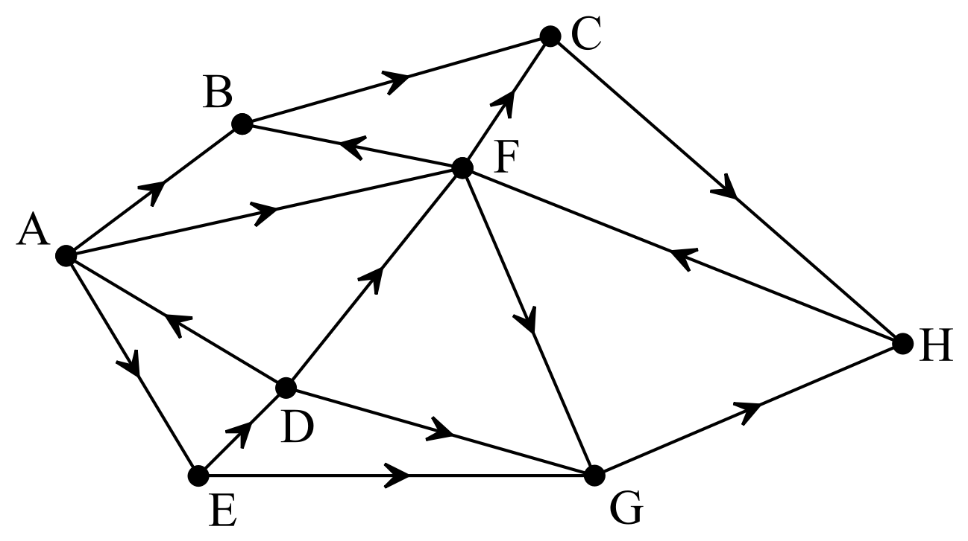

* 1. Determine the Adjacency Matrix C1. [8]

|  |  |  |  |  |  |  |  |  |  |  |  |  |  |  |  |  |  |  |
| --- | --- | --- | --- | --- | --- | --- | --- | --- | --- | --- | --- | --- | --- | --- | --- | --- | --- | --- |
|  |  |  | **To** | | | | | | | | | | | | | | |  |
|  |  |  | A | B | | C | | D | | E | | F | | G | | H | |  |
| **From** | A |  |  | |  | |  | |  | |  | |  | |  | |  |  |
| B |  |  | |  | |  | |  | |  | |  | |  | |  |  |
| C |  |  | |  | |  | |  | |  | |  | |  | |  |  |
| D |  |  | |  | |  | |  | |  | |  | |  | |  |  |
| E |  |  | |  | |  | |  | |  | |  | |  | |  |  |
| F |  |  | |  | |  | |  | |  | |  | |  | |  |  |
| G |  |  | |  | |  | |  | |  | |  | |  | |  |  |
| H |  |  | |  | |  | |  | |  | |  | |  | |  |  |

* 1. Use your ClassPad to complete the Connectivity Matrices below. [6]

|  |  |  |  |  |  |  |  |  |  |  |  |
| --- | --- | --- | --- | --- | --- | --- | --- | --- | --- | --- | --- |
|  |  |  | A | B | C | D | E | F | G | H |  |
| **C2 =** | A |  |  |  |  |  |  |  |  |  |  |
| B |  |  |  |  |  |  |  |  |  |  |
| C |  |  |  |  |  |  |  |  |  |  |
| D |  |  |  |  |  |  |  |  |  |  |
| E |  |  |  |  |  |  |  |  |  |  |
| F |  |  |  |  |  |  |  |  |  |  |
| G |  |  |  |  |  |  |  |  |  |  |
| H |  |  |  |  |  |  |  |  |  |  |

|  |  |  |  |  |  |  |  |  |  |  |  |
| --- | --- | --- | --- | --- | --- | --- | --- | --- | --- | --- | --- |
|  |  |  | A | B | C | D | E | F | G | H |  |
| **C3 =** | A |  |  |  |  |  |  |  |  |  |  |
| B |  |  |  |  |  |  |  |  |  |  |
| C |  |  |  |  |  |  |  |  |  |  |
| D |  |  |  |  |  |  |  |  |  |  |
| E |  |  |  |  |  |  |  |  |  |  |
| F |  |  |  |  |  |  |  |  |  |  |
| G |  |  |  |  |  |  |  |  |  |  |
| H |  |  |  |  |  |  |  |  |  |  |

We could keep examining further matrices, but we will stop at this point. Next we will determine the total reachability at this point in time. Complete the following matrix representing the totals so far.

|  |  |  |  |  |  |  |  |  |  |  |  |
| --- | --- | --- | --- | --- | --- | --- | --- | --- | --- | --- | --- |
|  |  |  | A | B | C | D | E | F | G | H |  |
| **Total** | A |  |  |  |  |  |  |  |  |  |  |
| B |  |  |  |  |  |  |  |  |  |  |
| C |  |  |  |  |  |  |  |  |  |  |
| D |  |  |  |  |  |  |  |  |  |  |
| E |  |  |  |  |  |  |  |  |  |  |
| F |  |  |  |  |  |  |  |  |  |  |
| G |  |  |  |  |  |  |  |  |  |  |
| H |  |  |  |  |  |  |  |  |  |  |

* 1. Complete the Reachability Table below (for this point in time). [4]

|  |  |  |  |  |  |  |  |  |  |
| --- | --- | --- | --- | --- | --- | --- | --- | --- | --- |
| Vertex | A | B | C | D | E | F | G | H |  |
| Reachability |  |  |  |  |  |  |  |  |  |

* 1. List all the associated paths that go to Vertex D at this point. [3]

1. (13 marks)  
   A landscape garden is planted in five tiers A, B, C, D and E. Tier A is the highest, B is the second highest, followed by C, then D and lastly E.  
     
   Only Tier A is watered and the water from A flows down to the other levels. The Adjacency Matrix shows the possible paths the water can take.

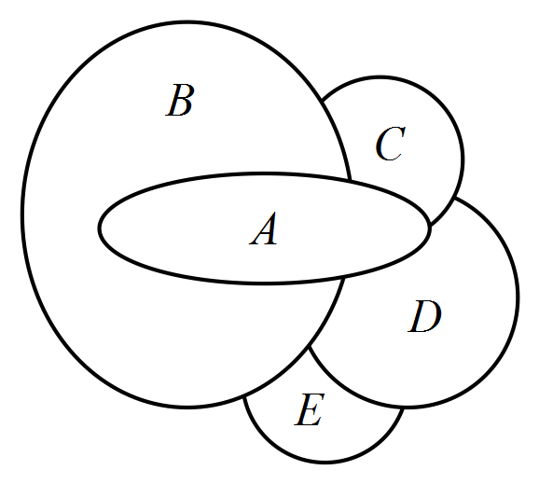

* 1. Draw a directed graph where the vertices represent the tiers and the edges represent the paths the water can take. [4]
  2. Draw the Adjacency Matrix. [5]
  3. Find C2 for this graph. [2]
  4. Name the possible paths from A to E. [2]

A graph can also be used to determine dominance. This is similar to reachability, just a change in context and one change in method.

1. (11 marks)  
   Four basketball players, Abbie, Bess, Cath and Denise, play off against each other in a series of one-on-one basketball games. In these games,

* Abbie beats Bess
* Bess has no wins
* Cath beats Bess and Denise
* Denise beats Abbie and Bess

This information is shown in the dominance graph below.

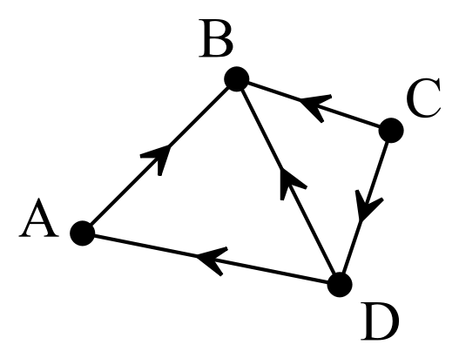

* 1. Find the first dominance matrix, D1, showing the one-step dominance between players. [4]
  2. Find the second dominance matrix, D2, showing the two-step dominance between players. [2]
  3. Find the dominance matrix by summing D1 and D2. [2]
  4. Find the dominant player by summing the rows of the dominance matrix. [3]

1. (14 marks)  
   There are four different brands of cereal that are labelled W, X, Y and Z. The cereals are rated at a blind tasting and it is found that

* W is rated higher than Y and Z
* X is rated higher than W and Y
* Y is rated higher than Z
* Z is rated higher than X

1. Draw a dominance digraph where a cereal has dominance if it is rated higher. [4]
2. Determine the one-step dominance matrix. [4]
3. Determine the two-step dominance matrix. [2]
4. Find the dominance matrix D1 + D2 and use this result to find the dominant cereal. [4]

**End of Investigation**